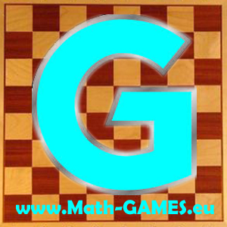
INVITATION
I invite you to the
Fifth Transnational Project Meeting
of the Erasmus+ project:
Math-GAMES - Games And Mathematics in Education for adultS Compendiums, Guidelines and Courses for Numeracy Learning Methods Based on Games
(2015-1-DE02-KA204-002260)

Each partner has to send its coordinator.

Programme

Date: Friday, 20th of January to Monday, 23rd of January 2017

Place: Cerveteri – RM – Istituto Comprensivo Cena – Via Settevene Palo 338

Airport: Rome FCO, Rome CIA

Website: www.math-games.eu

Aims of the meeting
- Evaluation of the Math-GAMES Numeracy Learning Guidebook in English
- Translation of the Learning Guidebook in national language
- Talk about the working process including the quarter reports and the administration
- Preparation of the next meeting, next work to do

Timetable (subject to modification)

Fr 20.01.2017 Arrival Day

Get-together (optional, place and time to be decided)

Sat 21.01.2017 First Working Day

9:30 Meeting at school

9:40 Working time
- The coordinator will make a short presentation about the progress of the project
- Each country will present its work in 5 minutes
- Discuss improvements, printing of the books
- Discuss the output (O2) and the coming timetable (translation), deadlines

13:00 Lunch at school

13:30 Meeting resumes

15:00 Visit to the “Banditaccia Necropolis”

19:30 Dinner in a typical restaurant in Cerveteri (winery)

Sun 22.01.2017 Second Working Day

10:00 Work on project details at school

13:00 Lunch and free time to visit Rome

Mon 23.01.2017 Departure Day

Contact person: Domelita Di Maggio

0039 3396387938

domelita.dimaggio@gmail.com

